Classification-LogisticRegression.ipynb

Tutorial name :- Predict whether consumers will buy houses or not, given their age and salary.

Q1.
From the graph we can see that for some of the consumers who had high probability of buying the house did not buy it and some consumers who had very less probability bought it and for some of the consumers it is predicting a probability of 50%.
This issue can be solved by training the model with more samples

Q2.
Model fitting is a measure of how well a machine learning model generalizes to similar data to that on which it was trained. A model that is well-fitted produces more accurate outcomes.

Prediction refers to the output of an algorithm after it has been trained on a historical dataset and applied to new data when forecasting the likelihood of a particular outcome

Q3.
There are 24 true positives in the classifier result.
A true positive is an outcome where the model correctly predicts the positive class , a true negative is an outcome where the model correctly predicts the negative class .

Q4.
The idea behind StandardScaler is that it will transform our data such that its distribution will have a mean value 0 and standard deviation of 1. In case of multivariate data this is done feature-wise (in other words independently for each column of the data).

Tutorial name – Predict house prices based on area of the house

Q1.
No , the trained model is not that accurate, because MSE is more and for many test cases the model doesn’t predict correctly.

Q2.
For 1700 the price is about 80000 and for 1900 the price is about 88000

Tutorial name – Insurance Premium Calculation based on age

Q1.
For this dataset of insurance premium calculation ‘Polynomial regression’ suits well , since the model predicts correctly for the test data.

Q2.
Polynomial regression with degree 4 interprets the best result.

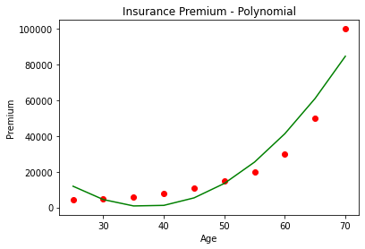
Degree 2
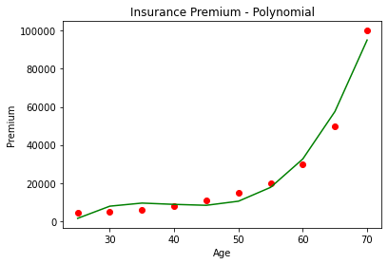
Degree 3
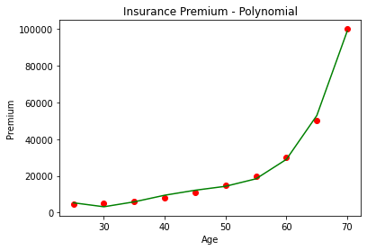
Degree 4
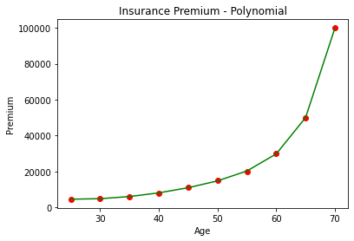
Degree 10
Q3.
Predicted insurance premium for ages
29 is [7059.19813511]
45 is [20906.06060606]
53 is [33846.66666667]
80 is [77521.21212121]

